# Network Science

## HW-1 (12 pts)

### Exercise 1 (2 pts)

A simple connected graph consists of $n$ vertices.

1. What is the maximum possible number of edges it could have?
2. What is the minimum possible number of edges it could have?

### Exercise 2 (2 pts)

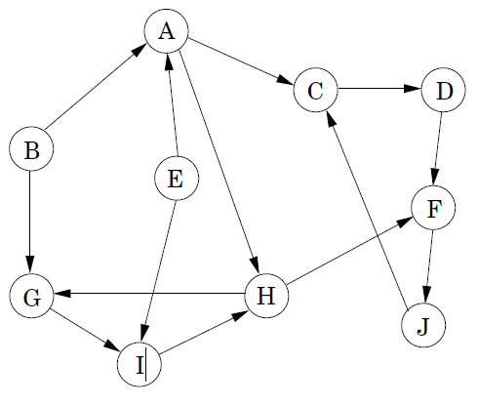

A directed graph is *strongly connected* if for each pair of vertices $u$ and $v$, there is a path from $u$ to $v$ and there is a path from $v$ to $u$. Consider the directed graph on the right. Is it strongly connected or not? Why or why not?

### Exercise 3 (2 pts)

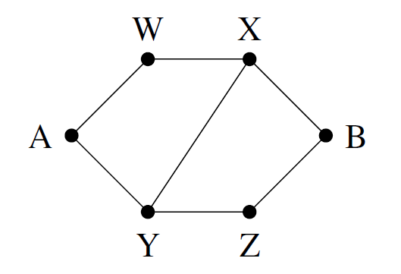

The graph is *bipartite* if the set of its vertices can be divided into two disjoint subsets such that every edge connects a vertex from one subset with a vertex from the other subset. Consider the graph on the right. Is it bipartite or not? Why or why not?

### Exercise 4 (2 pts)



Calculate the closeness centrality of each vertex in the graph on the right.

### Exercise 5 (2 pts)



Calculate the betweenness centrality of each vertex in the graph on the right.

### Exercise 6 (2 pts)

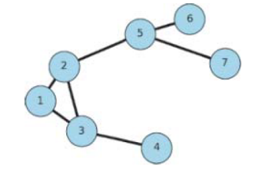

Consider the graph on the right.

1. Find all vertices with the largest closeness.
2. Find all vertices with the largest betweenness.